Featuring: Glacier National Park and

**Join your travel friends with Seniors On The Go Travel for this Western Adventure! Email for more information: cmstokes@bellsouth.net**

**DAY 1 – SUNDAY, AUGUST 18th :** ( L, D)

Fly into Missoula MT, and meetyour coach and depart for Butte. We’ll have an included lunch in route.Upon our arrival, we’ll have a quick tour of the stunning **Holy Trinity Serbian Church and** then head to **Butte Copper King Mansion for a tour on the ‘Richest Hill in the country’.** *It was built for William A. Clark, one of the principal developers of copper mining in Butte. More money was spent on the Mansion then the original courthouse in 1883. It’s listed on the National Historic Register. Check into your* hotel. Then have dinner at **Sparky’s Garage**, where we will dine in a nostalgic spot like back in time!

**DAY 2 – MONDAY, AUGUST 19th :**  (B,D)

Breakfast at the hotel. Take a **Narrated Historic Trolley Tour of Butte** and learn about the fascinating history of the area. Next stop is the **World Museum of Mining**. A *22+ acre museum with exhibits portraying more than a century of American history and brings that history to life . Displays focus on the cultural and ethnic history of a mining town while the mine yard provides guests with a look of the history of mining technology.*

Depart for **Kalispell**. Lunch on your own along the way. Stop at the **Miracle of America Museum. The dream of one man….** *the Museum is made of up of 10 galleries and thousands of historic and nostalgic collection from military to Americana. From the authentic 50’s Diner to World War ll Tanks! This unique attraction is a must see!* Check into the **Red Lion Kalispell** for your 3-night stay.

Dinner tonight is at the **Dusty Star Saloon.** A local favorite!

**DAY 3 – TUESDAY, AUGUST 20TH:** (B)

Breakfast at the hotel. Depart today for **Glacier National Park**! *Explore the 50 mile long* ***Going to the Sun Road on the Famous Red Jammers, an iconic way to see the park!*** *Glacier National Park encompasses more than 1 million acres boasting hundreds of sparkling lakes and cascading waterfalls; jagged, glacial-carved peaks. Stunning views and rolling foothills with past glacial-carved terrain before cresting the Continental Divide at 6,646-foot Logan Pass.* Stops include **Apgar Visitors Center, Apgar Village, stunning lake views of crystal blue water, and the Historic Lake McDonald Lodge**. Lunch and dinner on your own.

**DAY 4 – WEDNESDAY, AUGUST 21st :**  (B, L)

Breakfast at the hotel. This morning relax and have some free time. You can stroll on your own in historic downtown Kalispell! Later we will tour the **Conrad Mansion** *- A fearless Montana pioneer and businessman, Charles E. Conrad made his fortune as a Fort Benton freighter and trader on the banks of the Missouri River. In 1892, Charles Conrad founded the town of Kalispell and together with his wife Lettie, built their dream home in the backdrop of the Montana wilderness. The mansion is over 13,000 sq ft and was ahead of its time with electricity and plumbing. You’ll enjoy this beautiful home!*

**Explore Western Montana!**

**August 18 - 24, 2024**

**7 Days/6 nights**

Yellowstone TV Series Sites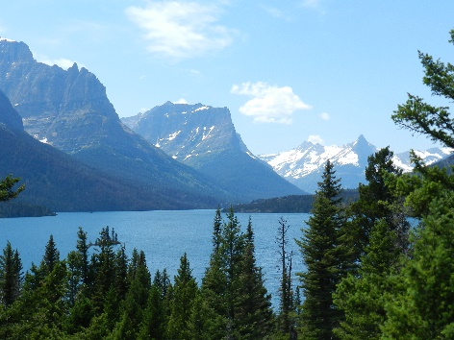

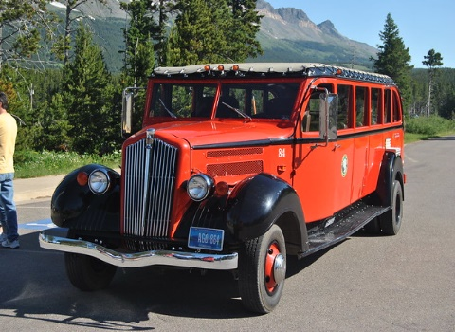

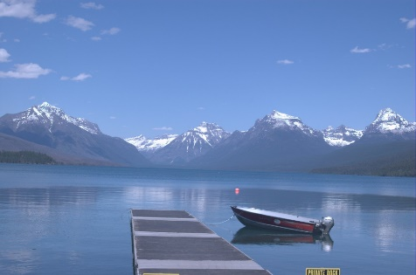

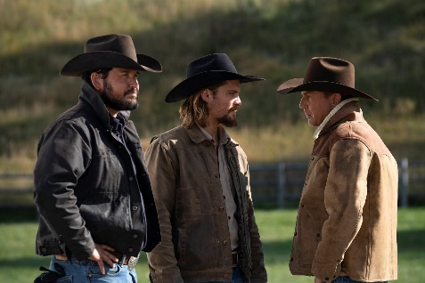

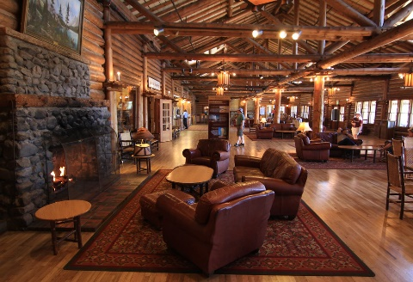

Tour Highlights & Inclusions: ROUND TRIP PRIVATE TRANSPORTATION • 6 NIGHTS LODGING • 13 MEALS: 6 BREAKFASTS, 3 DINNERS, 4 LUNCHES • ADMISSION TO LISTED ATTRACTIONS • TAXES & MEAL GRATUITIES • BAGGAGE HANDLING • ROUND TRIP AIRFARE FROM ATLANTA.

**NOT INCLUDED**: AIRLINE BAG FEES • DRIVER / GUIDE GRATUITY • TRIP CANCELLATION PROTECTION  **\*Tour is rated an activity level 3 -** Medium Level: medium walking, possible stairs, short walks;

LOCAL AIRPORT TRANSFER IN ATLANTA IS NOT INCLUDED BUT WILL BE ARRANGED WITH THE GROUP.

**Trip cost: $2899 per person based on two people in the room.**

**$3549 per person single room – limited availability, so register soon for these rooms.**

**Per Person Deposit - $400 due by 11/20/23 along with your registration; Make check out to Seniors On The Go Travel ; Insurance available and must be paid with deposit: Age 60-69: $299;**

**age 70-74: $319; Age 75-79: $359; Age 80-84: $459; Age 85 + $579; Please include birthdate!!**

**\*\*\*\*\*\*\*\*\*Final Balance and Full Payment Due March 2, 2024\*\*\*\*\*\*\*\*\*\*\*\***

**\*\*\*Seniors On The Go will send you a link to pay the final balance by credit card by late February\*\*\***

**Seniors On The Go Travel, 785 Marbrook Dr., Lawrenceville, GA 30044**

**Trip is operated by Western Pleasure Tours but please sign up at above address.**

**Name: ________________________________ Roommate: __________________________________**

**Address: ___________________________________________________________________________**

**Cell phone: _____________________________ Email: _____________________________________**

**Special requirements: ________________________________________________________________**

**Insurance: ______ Yes; Birthdate: ____________**

**DAY 4 cont……….**

*Then we head up to the quaint high-end town of* ***Whitefish*** *where will have lunch at the beautiful Lodge at Whitefish Lake. Afterwards you can e*xplore the lodge or head to downtown Whitefish for a wonderful experience in the historic town. It’s filled with shops, cafes, coffee shops and restaurants. There will be time to explore downtown and we’ll then return to Kalispell for dinner on your own*.*

**DAY 5 – THURSDAY, AUGUST 22nd :** (B, L, D)

Breakfast at the hotel and check out. Today we will tour the [**Ninepipes Museum of Early Montana History**](https://ninepipesmuseum.org/about-us/#:~:text=The%20Ninepipes%20Museum%20of%20Early,early%20trading%20post%2C%20the%20St.)**.** After the tour you can walk the trail outside, shop at Great Gray Gifts Boutique next door, or take in the sights of the Ninepipe National Wildlife Refuge. **Lunch is included at the Allentown Restaurant** next door. Depart for Missoula with a stop at **Big Sky Sasquatch** for yummy Huckleberry products! We’ll then check in to our hotel and have dinner at the Paradise Falls Restaurant.

**DAY 6 – FRIDAY, AUGUST 23RD :** (B, L)

Breakfast at the hotel. This morning as we head to Darby, Montana, home of **Yellowstone Dutton Ranch – Chief Jospeh Ranch.** *The ranch is one of the main characters on the show, and its scope and scale make it that way.” That said, the ranch is neither owned by Kevin Costner nor truly named the Dutton ranch when the cameras stop rolling. The 5,000-square-foot mansion is indeed located in Montana (near Darby) and is more than 100 years old. Originally owned by William S. Ford of the Libbey-Owens-Ford Company (LOF), which specialized in glass production, the expansive property now*[belongs to Shane and Angela Libel](https://nypost.com/2018/07/13/montana-log-mansion-brings-splendor-to-yellowstone/)*. In fact, the Libels live in the large log structure when the show is not being filmed. The Old West town of*[**Darby**](https://glaciermt.com/community/darby)*is a must-stop. Walk the wooden sidewalks that lead to local breweries, fantastic local fare and antiques along with an old-fashioned candy store. Or stop in at*[Double H Custom Hat Company](https://www.doublehhats.com/) *and get a custom cowboy hat made.* **Lunch is included in Darby!**

**Next stop – Hamilton -** *Downtown Hamilton is Yellowstone, home to the Montana Livestock Association where Kayce is commissioner. It’s a beautiful town with lots of historic buildings****.****We then d*epart for Florence with a stop at another famed Yellowstone location - Glen’s Café!**!** It is the location where John Dutton buys a steak dinner for his arch nemesis Garrett. We will stop for a photo op and we take homemade pie with us on the bus! Dinner is on your own **in Missoula** this evening.

**DAY 7 – SATURDAY, AUGUST 24th :**  (B)

Breakfast at the hotel and check out. This morning we have a short guided tour that includes some of the Yellowstone TV Series sites and a look at the famous murals in the Capitol Building. You’ll see Ruby’s Café, the community Medical Center andshots ofthedowntown streets. You’ll see the Courthouse, the building where Jamie’s Attorney General office is located, as well as the building where Beth has her office. The group will then make there way to the airport for your return journey home!