**Seniors On The Go Travel and Del Webb Off Our Rockers Travel Group presents:**

**American Cruise Lines Columbia River Cruise**

**June 22-30, 2025**

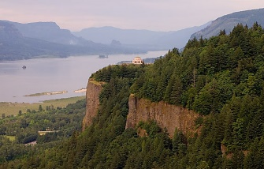 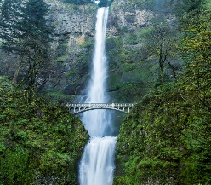 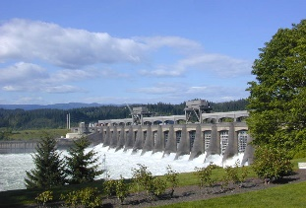 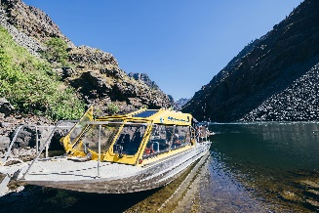 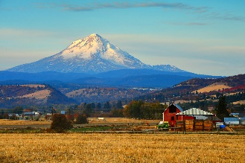

**Travel on the American West Riverboat from Clarkston, Oregon to Portland, Oregon**

Trip will fly in to Lewiston, Idaho and will fly home from Portland, Oregon area. There are currently no plans to actually be in the city of Portland.

This cruise will feature local history, stunning views along the scenic Columbia River, and stops at Clarkston, The Dalles, Kalama, Astoria and more. It’s truly the prettiest river I have ever cruised on. You’ll learn much about the Lewis and Clark expeditions as we travel along one of their routes to the Pacific Ocean. It’s also a riverboat with just about 200 people on board, including their staff, so you’ll love the relaxing experience on board. Includes all meals on board as well as beer and wine at lunch and dinner. Optional spirit packages are available. Along the way you’ll have at least one included tour at each port, with the option to purchase additional excursions as well.

Pre trip in Clarkston for the Hells Canyon and the Snake River airboat ride is available with an overnight at a local hotel.

We are doing this cruise a little different this year as many people had airline vouchers and insurance vouchers that they can use on the cruise. You will be purchasing your own air for the cruise, and I will offer assistance with dates and time; OR you can purchase air through American Cruise Lines. You can also purchase trip insurance thru them or reach out to me if you’d like to price shop it.

I can’t quote prices on this trip, but I can tell you that the cruise starts at about $5000 per person. You have several options on your cabin choices and you can talk to their representative about it as well.

I will help to arrange ALL the airport transfers, here in Atlanta, and out their as well. I will pass this information on to everyone who signs up once we secure the air. There will be a fee for this.

**Right now, there are 24 people who have signed up…. mostly by word of mouth!**

Please reach out to Elizabeth Prete to find out about the cruise. You can email her at: [elizabeth.prete@americancruiselines.com](mailto:elizabeth.prete@americancruiselines.com)

She will let you know all the details, and go over ALL the pricing. They are currently offering a $1000 credit per statement. She’s very knowledgeable about the cruise and is really helpful too. She’s been with the company 18 years.

She will then reach out to me to let me know that you have signed up and I will have your information. I will reach out to everyone in late October about flights, transfers etc.

This will be my 4th time on this river! I absolutely LOVE the scenery and the laid-back cruising atmosphere!

My information is [cmstokes@bellsouth.net](mailto:cmstokes@bellsouth.net) if you have any basic questions. Otherwise, please reach out to Elizabeth.

I want to thank Lynnnette Cannon for getting this cruise rolling! She’s the one who first spoke to Elizabeth! Thanks!! 😊